Ch4 – Mangoes Round The Year

ANSWER THE FOLLOWING QUESTIONS :

(i) Raju went to the market to buy bread . But as soon as he checks the packet of food he returned it immediately .
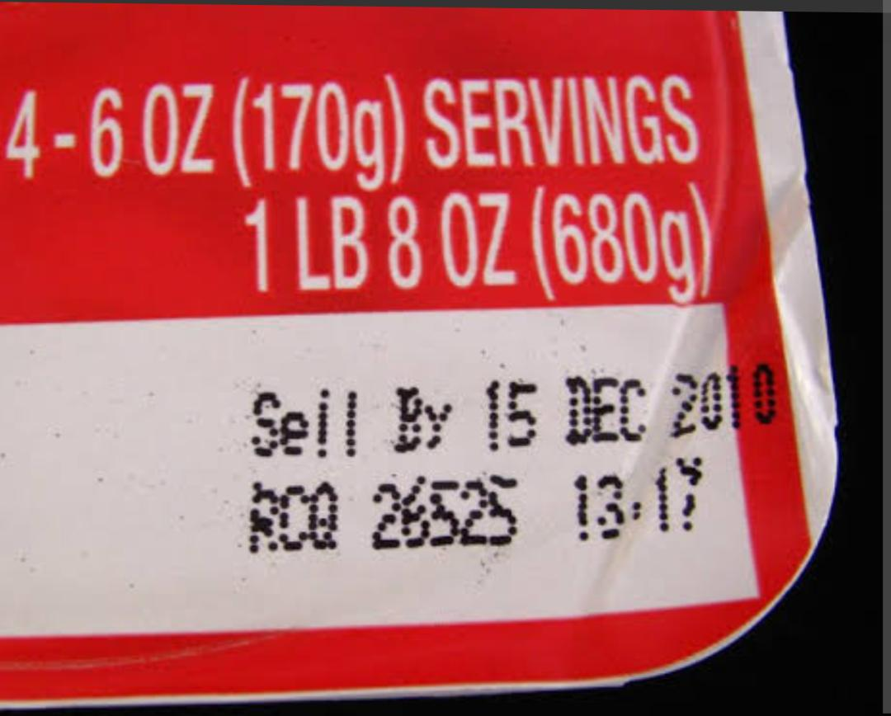
What information on the food package you should see before buying it?

Ans: Before buying food packages, check the following:
- Date of packaging
- Date of expiry
- Weight
ii) Some food spoil soon , some stay good for long time . By what way we can stop spoiling of food items ?
- Answer - Food gets spoiled due to action of bacteria and fungi which are present in our environment.
We can stop spoiling of food items by -
- We should keep perishable foods, like meats, dairy products, and cooked foods, in the refrigerator at a temperature
- It's important to store food in sealed containers and handle it with clean hands and utensils to reduce the chances of germs getting into the food.
iii) Name the conditions that help the germs to grow that spoil the food.
- Answer - various conditions are responsible for food spoilage such as bacteria, mold, yeast, moisture, light, temperature, and chemical reaction.
IV) Glass jars and bottles are dried well in the sun before filling them with pickles. Why is this done?
- Answer - If glass bottles are not dried in the sun, there will be the growth of micro-organisms, and this may cause the food to get decayed and unfit for consumption.
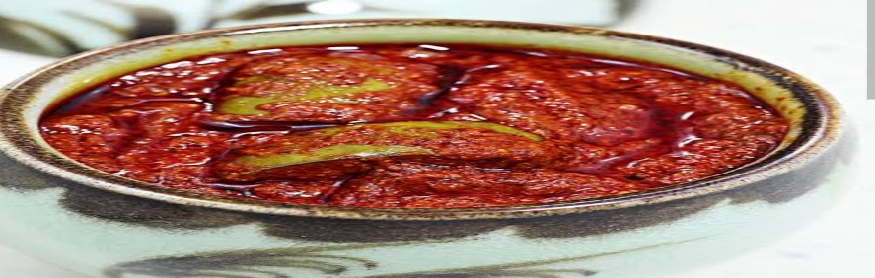
V) Puja’s grandmother makes mango pickle on every summer .Now puja is in class 5 and she is curious to know how her grandmother makes the pickle.

I) Name some products made by preserving mango .
II ) write the process and precaution taken for making mango pickle.
Answer by won .
VI ) Fill in the blanks:
(i) We must carefully check _____of packing before buying.
(ii) We must store onions and garlic in a _____ place.
(iii) Name any two food items that do not get spoiled for months. _____ ____.

